**Create Spring Boot Web Application for User Management System by using Following OUTPUT screens Shots?**

1. **Write Here Project structure with Required Files and Jars**
2. **Output Screens**

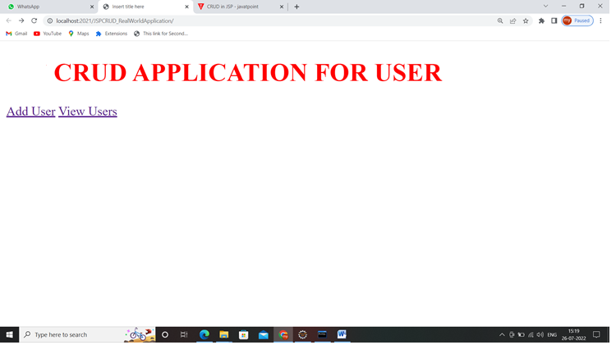

**View all users**

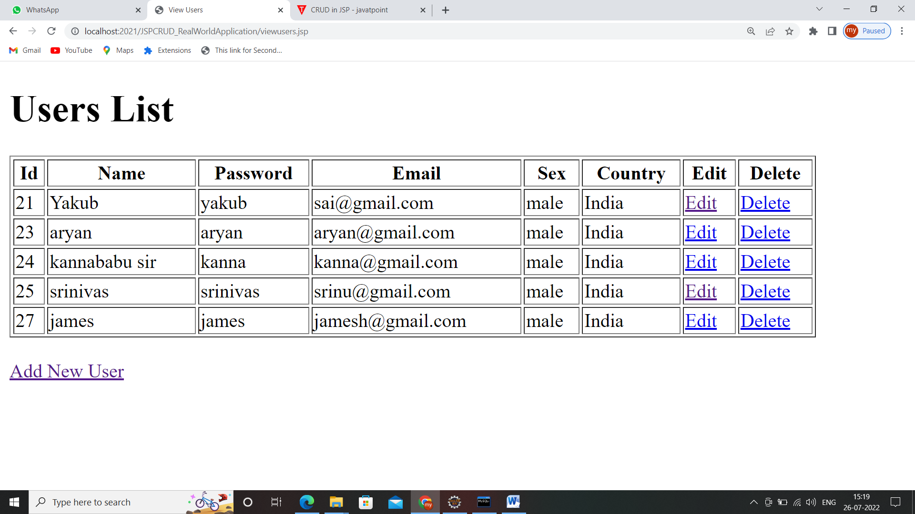

**Add new User**

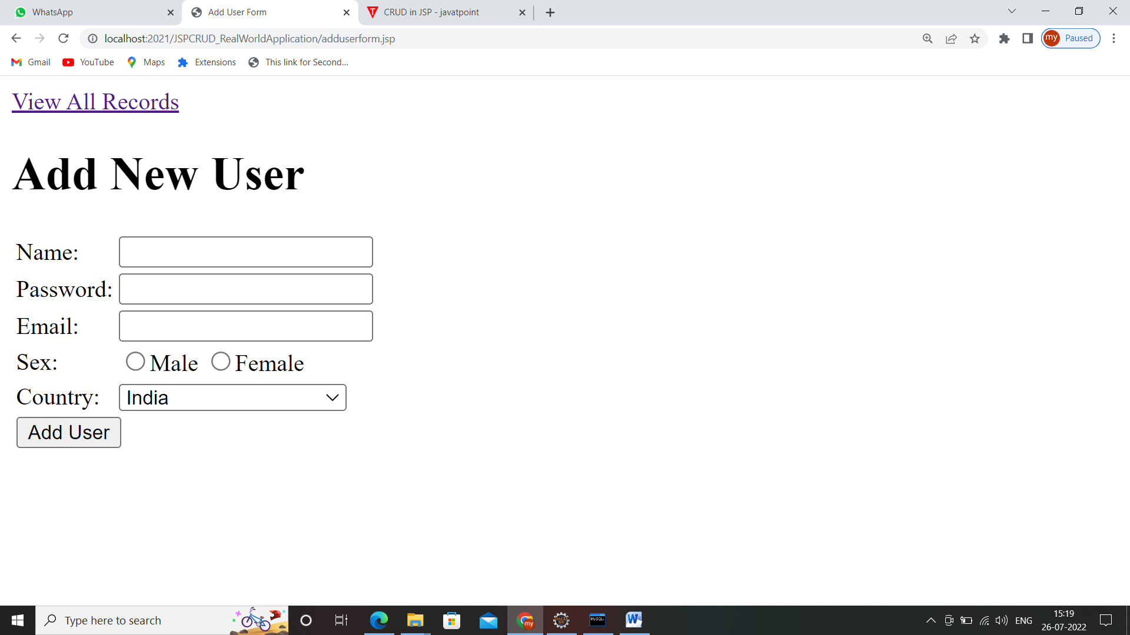

**Edit Form**

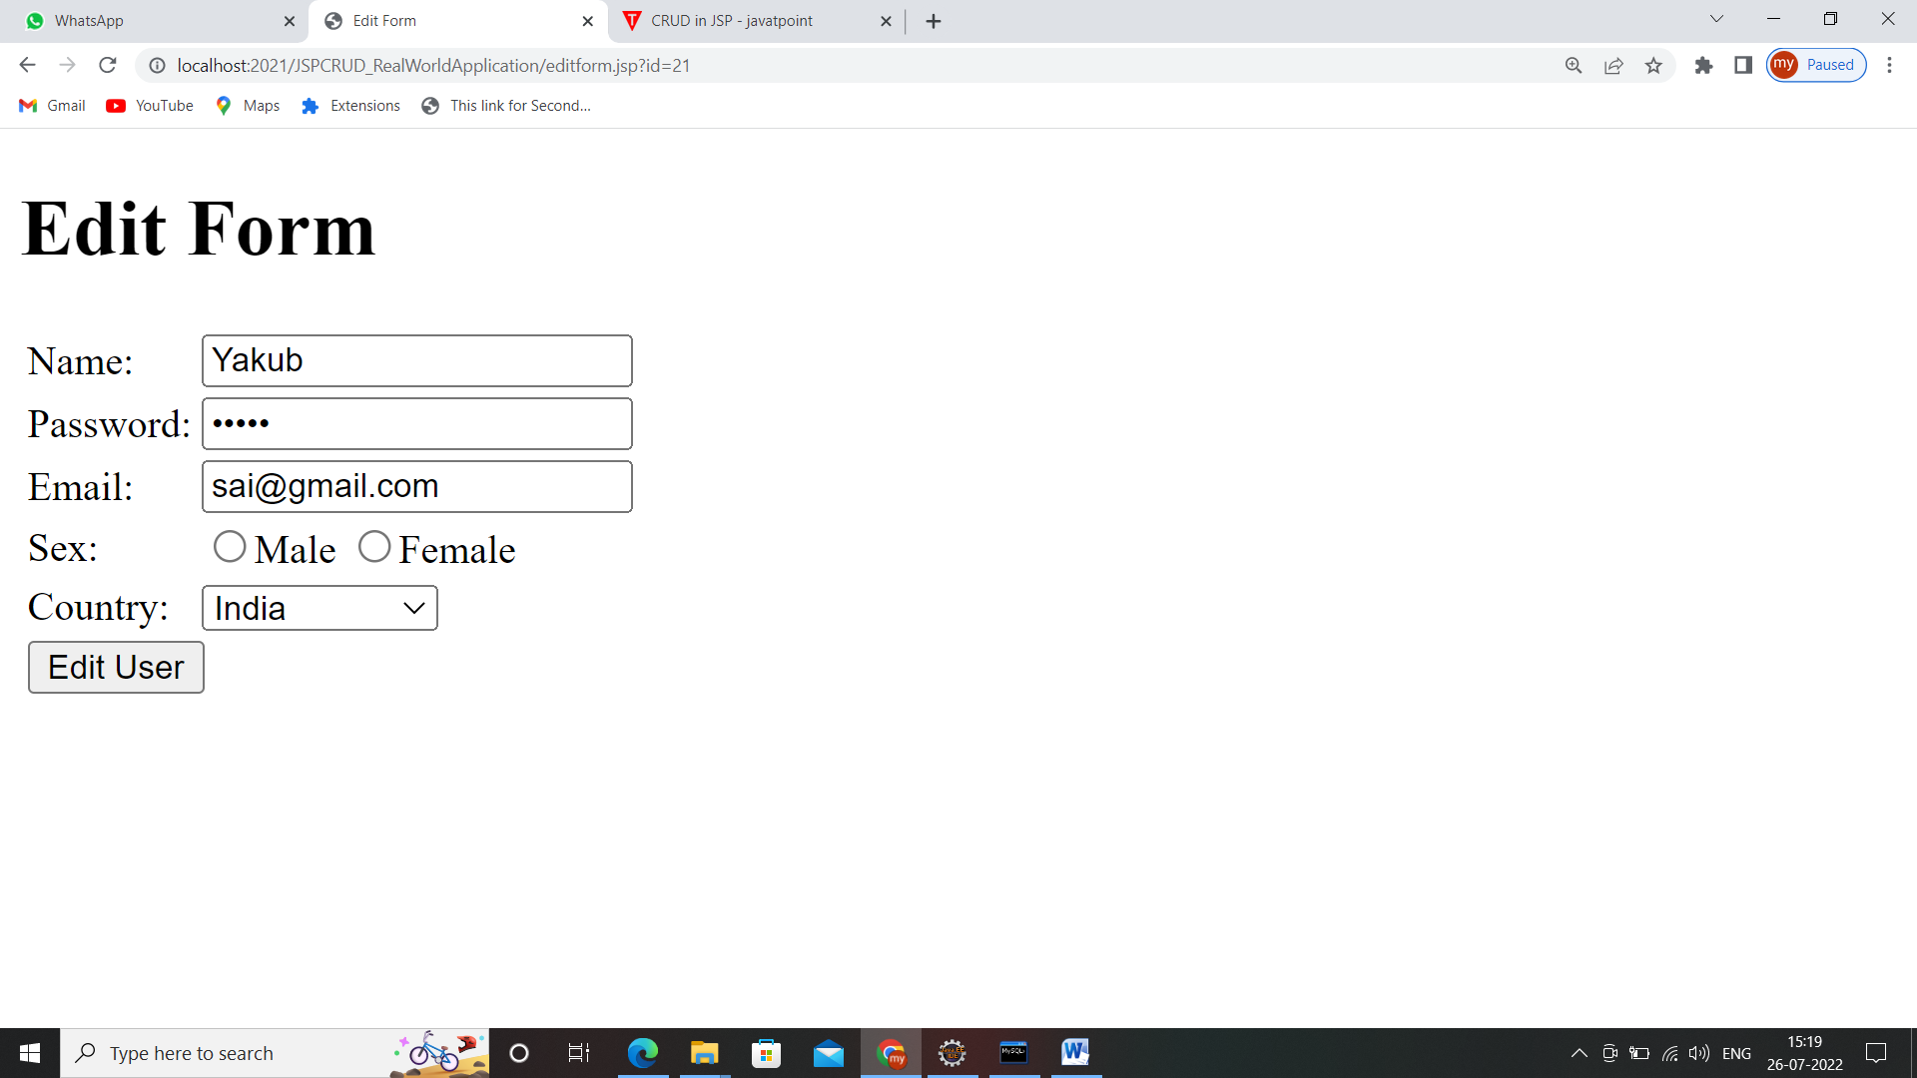

**After edit data**

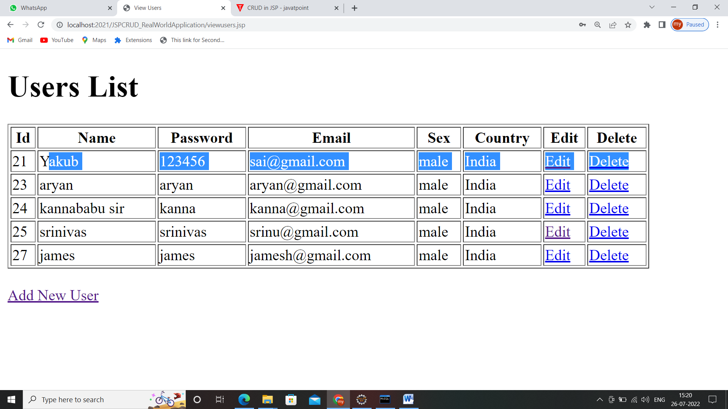

**Before delete**

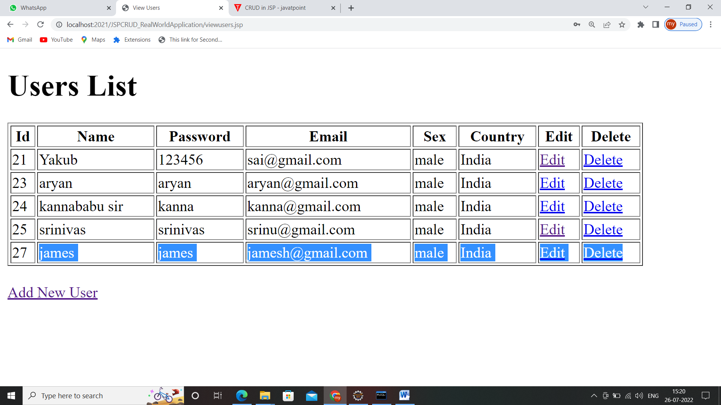

**After delete**

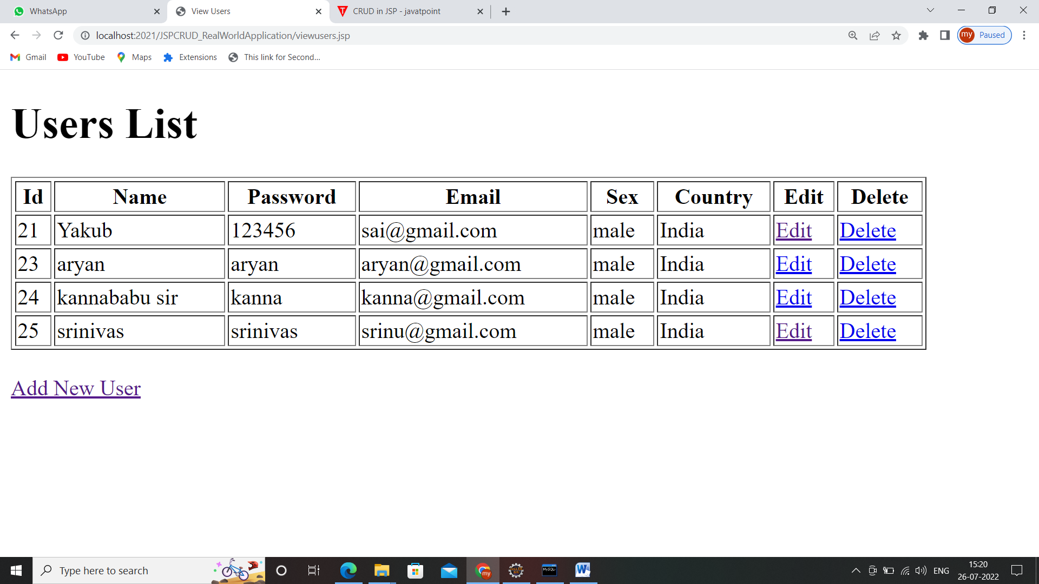

1. **Purpose of @RequestMapping Annotation?**
2. **Purpose of @RequestParam Annotation?**
3. **Purpose of @PatheVariable Annotation?**
4. **Purpose of @Autowired Annotation?**